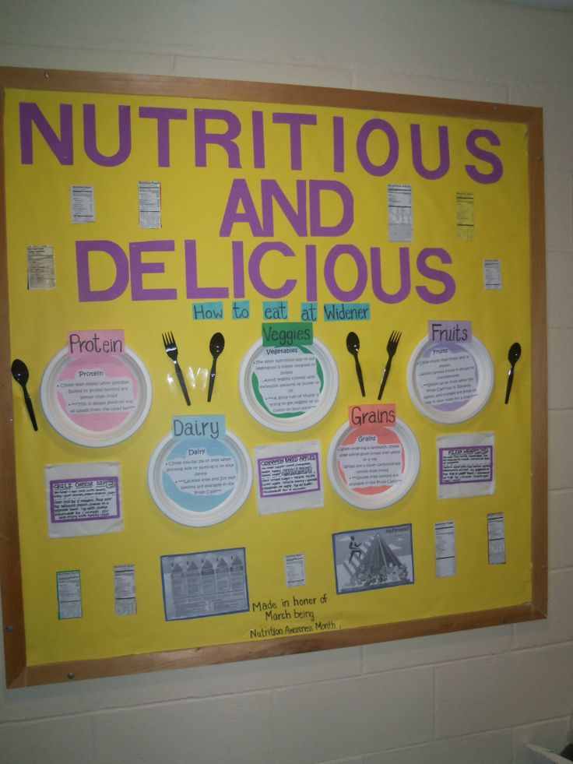
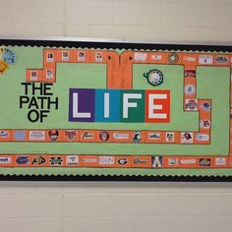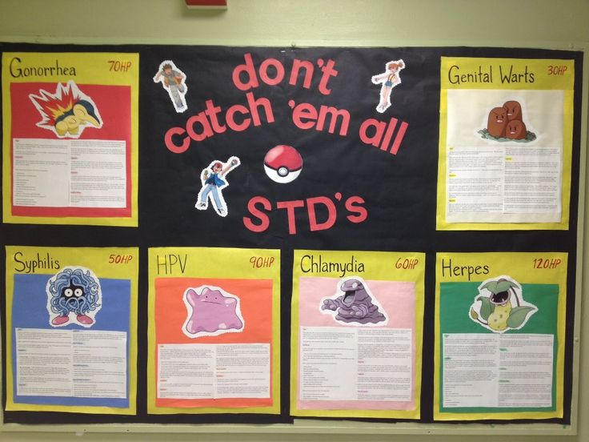

Please see me for more information regarding this opportunity and the expectations for this project. There is no presentation; you do not share the information - we post it for folks to read.
The following is a list of possible topics; please speak with me before beginning your project as someone else may have already selected that topic!
General expectations: must be in your own words, correctly spelled and typed information, contain a title and colorful images, correctly sited sources (minimum of 3 sources, the Internet may not be used as a source) and be sure to include your name and period #

B-board on how to take a resting and active pulse rate

B-board on what blood pressure is and why it is important to know yours

B-board on the main risk factors for cardiovascular disease

B-board on the importance of exercise in order to maintain a healthy life style

B-board on the importance of nutrition in order to maintain a healthy life style

B-board on the importance of weight management in order to maintain a healthy life style

B-board on ADHD

B-board on bi-polar disorder

B-board on SAD

B-board on OCD

B-board on panic disorder

B-board on phobic disorders

B-board on schizophrenia

B-board on bulimia

B-board on anorexia

B-board on gay, lesbian and bi-sexual (terms, difference b/t orientation & behavior, DOMA, etc)

B-board on transgendered, transsexual, transvestite (difference b/t gender & gender identity)

B-board on tips for quitting smoking

B-board on the drought

B-board on how to actually conserve water (high efficiency toilets vs shorter showers) ("if it is yellow, let it mellow-if it is brown, flush it down)

B-board on the importance of immunizations (new research-getting measles restarts the IS)

Bulletin Board Assignment worth:____________ due: ________________
Your bulletin board project may be displayed in the classroom on a bulletin board. If given as an assignment (vs extra credit) you will need to briefly (5-10 minutes) present the information you put on the board to the class.
You must create a colorful, creative and informative bulletin board presentation on your assigned topic.
You must be sure to consult reliable sources and to properly document them.
This includes any images used.
You should include your first and last name as well.
Everything on the bulletin board must be typed.
You should measure the board you will be using for the project /presentation.
Things to consider including: a title, images, typed information (who, what, when, where, why) about your topic and about your images, resources used (documentation of your sources)

Bulletin Board Assignment worth:____________ due: ________________
Your bulletin board project may be displayed in the classroom on a bulletin board. If given as an assignment (vs extra credit) you will need to briefly (5-10 minutes) present the information you put on the board to the class.
You must create a colorful, creative and informative bulletin board presentation on your assigned topic.
You must be sure to consult reliable sources and to properly document them.
This includes any images used.
You should include your first and last name as well.
Everything on the bulletin board must be typed.
You should measure the board you will be using for the project /presentation.
Things to consider including: a title, images, typed information (who, what, when, where, why) about your topic and about your images, resources used (documentation of your sources)

